Project Design Phase-II
Technology Stack (Architecture & Stack)
Date | 01-10-2026 | Team ID | SWTID-2026-5415
Project Name | Import Data Using Transform Maps (Spreadsheet) | Maximum Marks | 4 Marks
Technical Architecture: the project uses ServiceNow configuration capabilities together with a spreadsheet source.
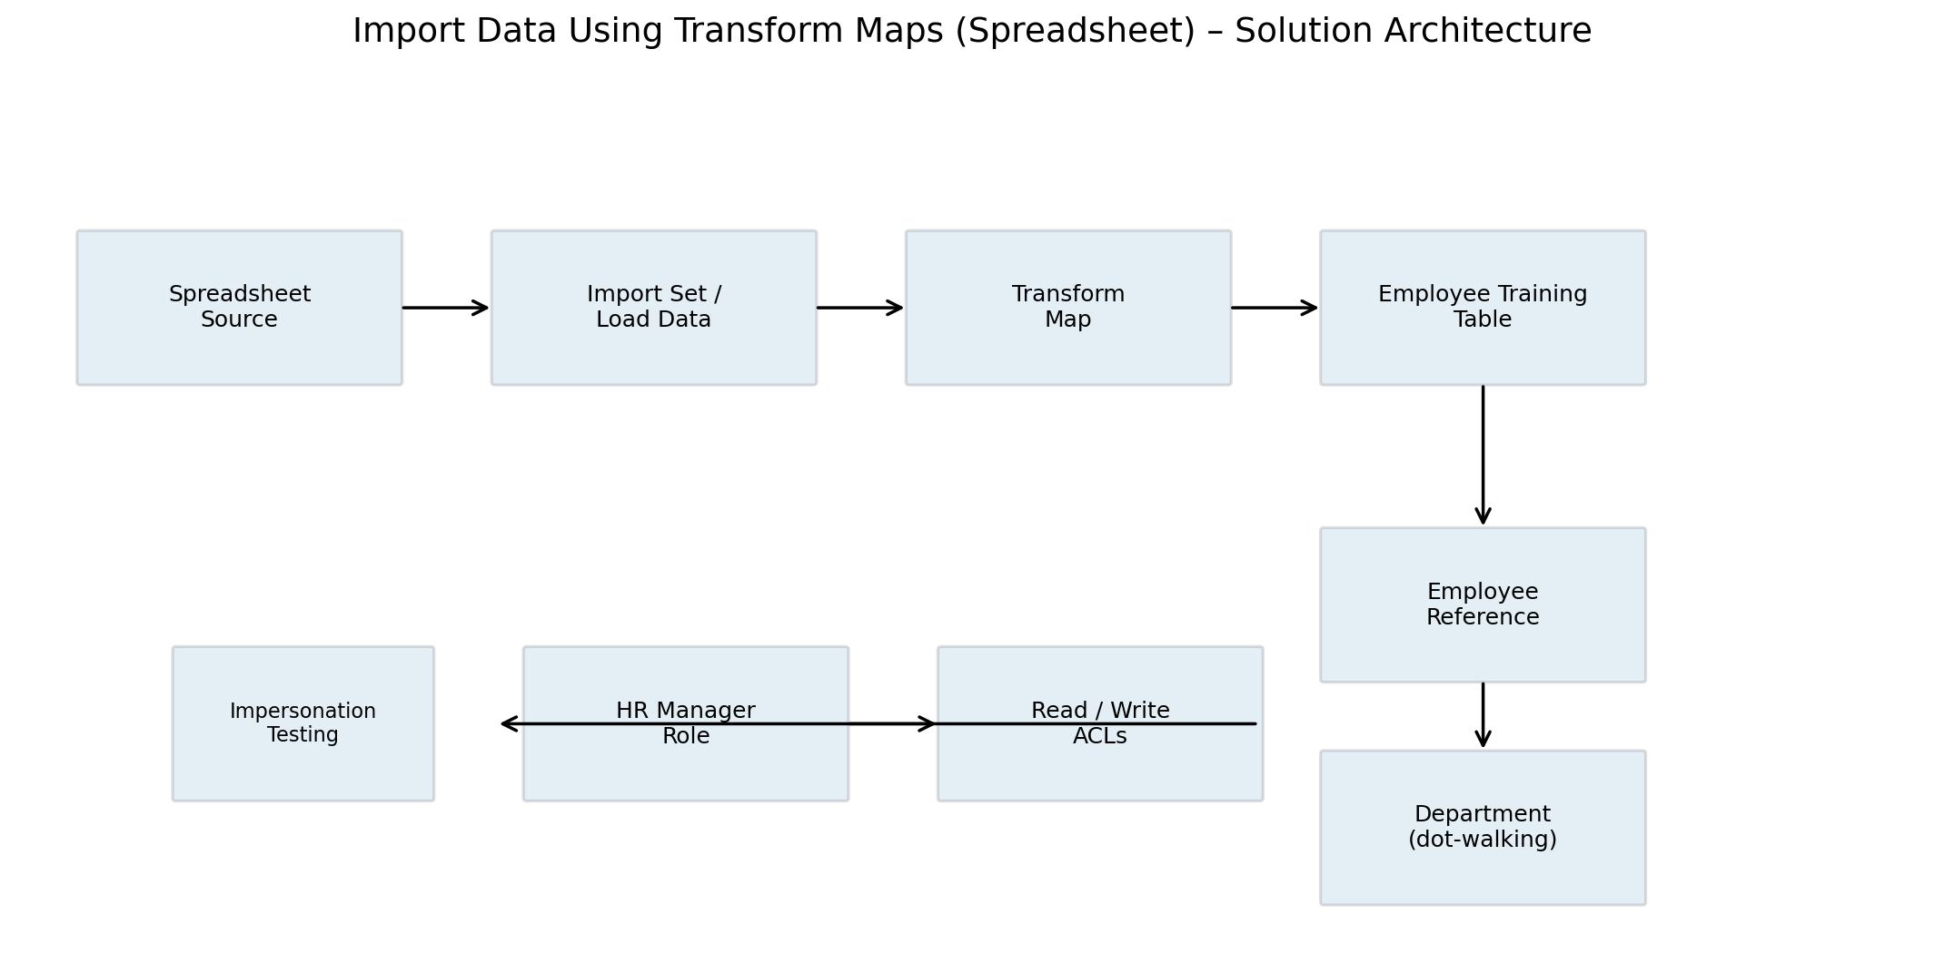

Table-1: Components & Technologies
S.No | Component | Description | Technology
1 | User Interface | ServiceNow forms and lists used to view/manage records. | ServiceNow UI
2 | Data Source | Spreadsheet containing source records. | Excel / Spreadsheet
3 | Import | Receives spreadsheet data into ServiceNow. | Import Sets / Load Data
4 | Transformation | Maps source fields to target fields. | Transform Map
5 | Data Relationship | Links records to the employee record. | Reference Field / sys_user
6 | Related Data | Reads Department through Employee. | Dot-walking
7 | Security | Controls record access. | Roles + ACLs
8 | Validation | Tests access behavior. | Impersonate

Table-2: Application Characteristics
S.No | Characteristics | Description | Technology
1 | Data Accuracy | Defined source-to-target mappings. | Transform Map
2 | Security | Role-based Read/Write control. | ACLs
3 | Maintainability | Configuration is separated into import, transformation and security. | ServiceNow
4 | Performance | Actual response/import measurements should be recorded from the completed instance. | Project test results

